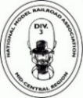 The ‟Miami Valley” Division 3 of the Mid-Central Region of the National Model Railroad Association proudly presents the 48th Original

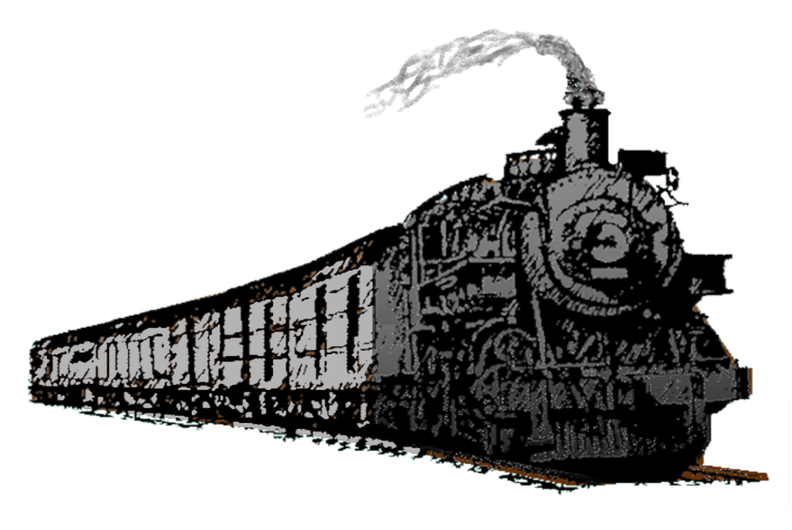 **Dayton Train Show**

The New Montgomery County

Fairgrounds & Events Center

645 Infirmary Road

Dayton, OH 45417

SM

Celebrating over 48 years of fun at one of the oldest and largest Model Railroad Shows in the Midwest!

**REFRESHMENTS AVAILABLE FREE PARKING**

**Admission: $8.00 per adult, children 12 and under free with paid adult.**



Multiple scale operating layouts

LEGO Trains and layouts

Historical Societies and Displays

Hundreds of Dealer Tables

Displays & Demonstrations

Prize Drawings

A train the kids can ride (Weather Permitting)

*Activities, layouts and vendors subject to change

***Special N scale display honoring the 80th Anniversary of D-Day.***

**November 2 & 3, 2024**

**Saturday 11AM To 5PM Sunday 11AM To 4PM**

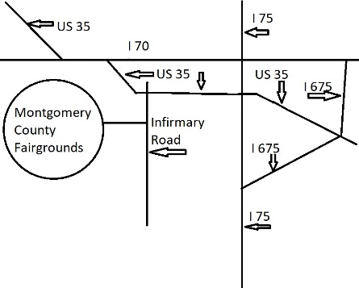

**Contact Us by:**

Email: NMRA.Div.3@gmail.com

Mail: Dayton Train Show

P. O. Box 341233

Beavercreek, OH 45434

Phone: (937) 424-6413

VENDOR INQUIRIES ARE WELCOME

Division 3, Mid-Central Region, National Model Railroad Association is a 501c(3) non-profit organization.

Want to know more?

Visit our Website: http://www.DaytonTrainShow.com Like us on Facebook at NMRA Annual Dayton Train Show



Website

09/29/23